CSBB 311
Project Report
on
AI-BASED ROAD DAMAGE AND POTHOLE DETECTION
Submitted By
Devam Kharbanda (241210037)
Gufran Alam (241210042)
Harshit Jhamb (241210047)
Abhiram Kavitharkika (241210058)
Krish Karandikar (241210065)

Under the guidance of Dr. Gautam Kumar

DEPARTMENT OF COMPUTER SCIENCE AND ENGINEERING
NATIONAL INSTITUTE OF TECHNOLOGY
DELHI

NATIONAL INSTITUTE OF TECHNOLOGY DELHI
Department of Computer Science and Engineering
Project Report
Student & Supervisor Details
Name of Student | Devam Kharbanda  Gufran Alam  Harshit Jhamb  Abhiram Kavitharkika  Krish Karandikar
Roll Number | 241210037, 241210042, 241210047, 241210058, 241210065
Course (Branch), Semester | B.Tech. (CSE) – 5th Semester
Project Code | CSBB 311
Supervisor’s Name | Dr. Gautam Kumar
Project details
Title of the project | AI-Based Road Damage and Pothole Detection

Table of Contents:
PROJECT APPROVAL
Declaration
ACKNOWLEDGEMENT
Chapter 1: Introduction
1.1 Problem description
1.2 Background
1.3 Scope of the Work
Chapter 2: Motivation
2.1 Industry Context and Trends
2.2 Market Demands
Chapter 3: Objectives
Chapter 4: Technology Used
4.1 YOLOv8 Object Detection Model
4.2 Dataset: CRDDC2022 (India)
4.3 Application and Supporting Libraries
Chapter 5: Methodology
5.1 Software Development
5.2 Application Integration
Chapter 6: Results
6.1 Future Scope
Chapter 7: Conclusion
Chapter 8: References

List of Figures
Figure Title Page No.
5.1.1 Overall pipeline of the road damage detection system
6.1 Precision-Recall curve on the validation set
6.2 Confusion matrix of the trained model
6.3 Per-class precision, recall and mAP@0.5
6.4 Ground-truth labels versus model predictions on a validation batch

PROJECT APPROVAL

This Project work entitled “AI-Based Road Damage and Pothole Detection” by Devam Kharbanda, Gufran Alam, Harshit Jhamb, Abhiram Kavitharkika and Krish Karandikar approved for the degree of Bachelor of Technology in Computer Science and Engineering

________________________
Supervisor
Dr. Gautam Kumar

Date: ____________________
Time: ____________________
Place: National Institute of Technology, Delhi

Declaration
We declare that this written submission represents our ideas in our own words. Where others' ideas or phrases have been included, we have adequately cited and referenced the sources. We also declare that we have adhered to all academic honesty and integrity principles and have not misrepresented, fabricated, or falsified any idea/data/fact/source in our submission. We understand that any above violation will cause disciplinary action by the Institute and can also evoke penal action from the authorities, which have thus not been properly cited, or from whom proper permission has not been taken when needed.

Devam Kharbanda  (241210037) | Gufran Alam  (241210042) | Harshit Jhamb  (241210047) | Abhiram Kavitharkika  (241210058) | Krish Karandikar  (241210065)

Date: ____________________

ACKNOWLEDGEMENT
We would like to express our sincere gratitude to our project guide and the faculty members of Computer Science and Engineering, National Institute of Technology, Delhi, for their continuous support, guidance, and encouragement throughout the development of this project. Their valuable insights and constructive feedback played a crucial role in the successful completion of the AI-Based Road Damage and Pothole Detection system.
First and foremost, we extend our deepest appreciation to our project guide, Dr. Gautam Kumar, for his constant support, expert guidance, and valuable suggestions at every stage of this project.
Sincere thanks also go to our fellow project teams. The healthy exchange of ideas, constructive discussions, and peer support played a significant role in refining our approach and enhancing the overall quality of our work.
This project has been a great learning experience, and we are grateful to everyone who played a part in making it a success.

Devam Kharbanda  (241210037) | Gufran Alam  (241210042) | Harshit Jhamb  (241210047) | Abhiram Kavitharkika  (241210058) | Krish Karandikar  (241210065)

Chapter 1: Introduction
Roads form the backbone of a country's transportation infrastructure, and their condition directly affects travel safety, vehicle maintenance costs, and daily commute efficiency. Over time, roads develop various forms of damage such as cracks and potholes due to heavy traffic load, weathering, poor drainage, and ageing of construction material. In India and many other countries, road damage is one of the leading contributors to accidents, vehicle breakdowns, and traffic congestion, yet its inspection and reporting is still largely a manual process.
Traditionally, road surveys are carried out by government authorities or municipal bodies through manual visual inspection, where trained personnel physically travel along road stretches and note down damaged sections. This method is slow, labour-intensive, expensive, and subjective — different inspectors may rate the same damage differently, and large road networks (especially rural and semi-urban ones) often go unsurveyed for months or years due to resource constraints.
With the rapid advancement of Artificial Intelligence and Computer Vision, it is now possible to automate this inspection process using image and video data. This project, “AI-Based Road Damage and Pothole Detection”, proposes a deep learning-based system that can automatically detect and classify road surface damage from images or video captured using a standard smartphone camera. The system focuses on identifying and categorizing damage into four major classes — Longitudinal Cracks, Transverse Cracks, Alligator Cracks, and Potholes — which are the most common and internationally recognized forms of flexible pavement distress. By automating detection and classification, this project aims to make road condition monitoring faster, cheaper, more consistent, and scalable to large road networks.

1.1 Problem description
Given an image or a video frame of a road surface, the task is to localise every damaged region with a bounding box and to assign it one of four damage classes. This is an object detection problem rather than a plain image classification problem, because a single frame may contain several instances of different damage types at different positions, and a maintenance engineer needs to know both what the damage is and where it is.
The difficulty of the problem comes from the nature of the data: cracks are thin, low-contrast structures that are easily confused with road markings, shadows, patches and joints, while potholes vary greatly in size, depth and appearance under different lighting and weather conditions. The model must also be fast enough to be used on video, and the results must be presented through an interface that a non-technical user can operate. This project addresses all three requirements: an accurate detector, a reproducible training and evaluation protocol, and a web application for image and video inputs.

1.2 Background
Automatic road damage detection has been studied for more than a decade, moving from hand-crafted image-processing methods (edge detection, thresholding, texture descriptors) to deep learning detectors. Convolutional Neural Network (CNN) based detectors such as Faster R-CNN, SSD and the YOLO family learn the visual appearance of damage directly from labelled examples and generalise far better than hand-crafted rules.
The Crowdsensing-based Road Damage Detection Challenge 2022 (CRDDC2022) and its RDD2022 dataset made large-scale, multi-country road damage data publicly available, with images captured by smartphones and annotated in the Pascal VOC format. Damage is annotated using standard codes — D00 (longitudinal crack), D10 (transverse crack), D20 (alligator crack) and D40 (pothole) — which correspond to the four classes used in this project. YOLOv8, released by Ultralytics, offers a good trade-off between accuracy and inference speed and is therefore well suited to a system that must process video.

1.3 Scope of the Work
The work reported here covers the complete pipeline from data to application: (i) conversion and filtering of the Indian subset of RDD2022 into the YOLO annotation format and creation of a reproducible training/validation split; (ii) training of a YOLOv8-small detector; (iii) quantitative evaluation using precision, recall, F1-score, mAP@0.5 and mAP@0.5:0.95 together with a confusion matrix; and (iv) a multi-page Streamlit web application that performs detection on uploaded images and videos. Realtime webcam detection is deliberately kept out of the current release and is planned after further lab evaluation (see Section 6.1).

Chapter 2: Motivation
The primary motivation behind this project is to replace slow, subjective and expensive manual road inspection with an automated, objective and low-cost alternative that only needs a smartphone camera. Potholes and cracks that go undetected grow with every monsoon and every heavy vehicle that passes over them; early detection allows inexpensive preventive repair instead of costly reconstruction, and directly reduces accidents and vehicle damage. The idea is to create a scalable and easy-to-use system that can eventually be adapted for municipal road surveys, campus road maintenance and citizen-reported road condition monitoring.

2.1 Industry Context and Trends
Governments and infrastructure companies are increasingly adopting data-driven pavement management. Survey vehicles equipped with cameras, LiDAR and inertial sensors are used on highways, and crowdsensing approaches that collect road images from ordinary vehicles and smartphones are growing in popularity. Computer vision is the key enabling technology in both cases because the volume of images collected is far beyond what human inspectors can review.
However, specialised survey vehicles are expensive and are rarely deployed on city streets, rural roads and campus roads. This creates an opportunity for lightweight, camera-only solutions built on open datasets and open-source detectors, which is the direction followed by this project.

2.2 Market Demands
There is clear demand for affordable pothole and crack detection among municipal corporations, public works departments, road contractors, fleet operators and navigation providers. Most commercial pavement-assessment systems are priced and designed for large agencies and rely on dedicated hardware. A solution that works on ordinary images and videos, runs on a commodity GPU or even a CPU, and is delivered through a simple web interface lowers the barrier for smaller organisations. The system developed in this project is designed to meet this need and to be extended with location tagging and severity estimation as the technology matures.

Chapter 3: Objectives
The primary objective of this project is to design and develop an AI-based system that automatically detects and classifies road surface damage from images and video, so that road condition monitoring becomes faster, cheaper and more consistent. The key aims of the project are:
- To develop an AI-based system capable of automatically detecting road surface damage from images/video captured using a standard camera.
- To classify detected damage into four distinct categories: Longitudinal Crack, Transverse Crack, Alligator Crack, and Pothole, using a supervised deep learning model.
- To train and evaluate a Convolutional Neural Network based object detection model (YOLOv8) on a labelled road damage dataset for high detection accuracy, using a data-preparation pipeline (annotation conversion, filtering of unused classes, controlled retention of background images and a fixed-seed train/validation split) that makes the experiments reproducible.
- To make the model robust to varying lighting, road surface and camera conditions, by handling image-format and orientation differences in the application (colour-space normalisation, EXIF rotation, resizing) and by exposing an adjustable confidence threshold.
- To present the detections in a structured, easy-to-read output showing the damage type and confidence of every detected region on annotated images and videos, as a first step towards maintenance planning.
- To evaluate the model's performance using standard metrics such as precision, recall, F1-score, and mean Average Precision (mAP).

Chapter 4: Technology Used
This project combines a modern deep learning detector, a public road damage dataset and a lightweight web framework. The key technologies are described below.

4.1 YOLOv8 Object Detection Model
YOLOv8 (You Only Look Once, version 8) from Ultralytics is a single-stage, anchor-free object detector. The whole image is processed in one forward pass of a CNN backbone and neck, and a decoupled head predicts the class and bounding box of every object directly, which makes the model very fast. We use the small variant, YOLOv8s, which has 168 layers (after fusing convolution and batch-normalisation), about 11.1 million parameters and 28.4 GFLOPs, and offers a good balance between accuracy and speed. The model is initialised from weights pre-trained on the COCO dataset and fine-tuned on road damage images (transfer learning), which speeds up convergence and improves accuracy on a dataset of limited size.

4.2 Dataset: CRDDC2022 (India)
The training data is the India subset of the RDD2022 dataset released with the Crowdsensing-based Road Damage Detection Challenge 2022. The India folder contains 7,706 road images captured with smartphones mounted on vehicles, each with a Pascal VOC XML file holding the bounding boxes and damage codes. The four damage types used in this project are listed in Table 4.1; other codes present in the dataset (e.g. D01, D11, D43, D44, D50) are not part of the target task and are discarded during preparation. The official test annotations are not public, so a validation split is created from the training images.
Table 4.1: Damage classes used in the project
Class ID | Dataset code | Damage type | Description
0 | D00 | Longitudinal Crack | Crack parallel to the road direction
1 | D10 | Transverse Crack | Crack perpendicular to the road direction
2 | D20 | Alligator Crack | Interconnected cracks forming a mesh
3 | D40 | Pothole | Bowl-shaped cavity in the surface

4.3 Application and Supporting Libraries
The application is written in Python. The main components are listed below.
- PyTorch: deep learning framework used by YOLOv8 for training and inference (torch 2.0.0).
- Ultralytics 8.0.201: provides the YOLOv8 implementation, training loop, validation metrics and result plotting.
- OpenCV (opencv-python-headless 4.8.0): image and video reading, resizing, colour conversion and writing of the annotated output video.
- NumPy and Pillow: array handling and image decoding, including EXIF-based orientation correction.
- Streamlit 1.28: builds the multi-page web interface (home page, image detection, video detection) with file upload, confidence slider and download buttons.
- Jupyter notebooks, BeautifulSoup and tqdm: used in the data-preparation, training and evaluation notebooks.
- NVIDIA RTX 2060 GPU (6 GB) with CUDA: hardware used for training and evaluation.

Chapter 5: Methodology
The system follows the pipeline shown in Fig 5.1.1: the dataset is converted and split, a YOLOv8s model is trained and evaluated, and the trained weights are served through a Streamlit web application. The training pipeline is organised as three notebooks (0_PrepareDatasetYOLOv8, 1_TrainingYOLOv8 and 2_EvaluationTesting) so that every step can be repeated.
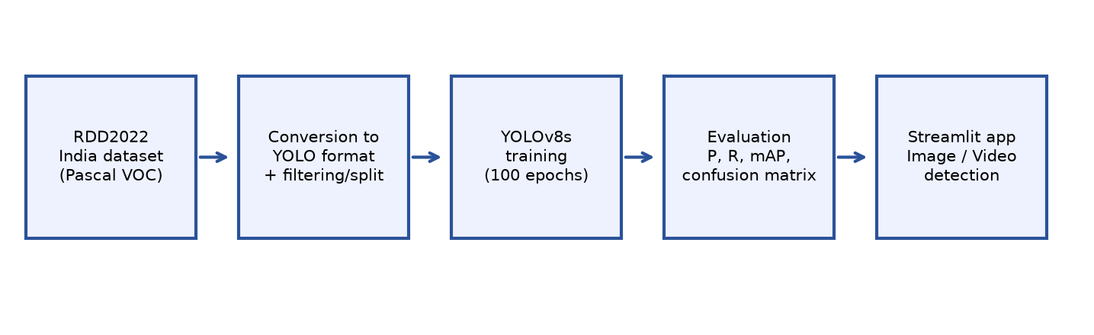
Fig 5.1.1: Overall pipeline of the road damage detection system

5.1 Software Development
Step 1 – Data preparation
- Annotation conversion: every Pascal VOC XML file is parsed, and each bounding box (xmin, ymin, xmax, ymax) is converted to the normalised YOLO format (class, x-centre, y-centre, width, height). Damage codes D00, D10, D20 and D40 are mapped to class IDs 0–3; all other codes are dropped.
- Background images: images without any usable damage are kept only up to 10% of the dataset size, so that the model still sees negative examples without being swamped by them.
- Train/validation split: the remaining images are shuffled with a fixed random seed (1337) and divided 90% / 10% into training and validation sets, with the corresponding images and label files copied into a YOLO directory structure (images/train, images/val, labels/train, labels/val).
- Dataset configuration: a YAML file lists the train and validation folders and the four class names, and is passed to the trainer.
Step 2 – Model training
The YOLOv8s model initialised from COCO pre-trained weights was fine-tuned on the prepared Indian road damage images with the hyper-parameters in Table 5.1. A cosine learning-rate schedule and a 5-epoch warm-up were used, the random seed was fixed for reproducibility, and checkpoints were saved every 10 epochs so that training could be resumed. Mosaic augmentation was disabled so that thin cracks are not cut and stitched across image borders.
Table 5.1: Training configuration
Parameter | Value
Base model | YOLOv8s (COCO pre-trained)
Epochs / warm-up epochs | 100 / 5
Batch size / image size | 32 / 640 × 640
Learning-rate schedule | Cosine
Mosaic augmentation | Disabled (0.0)
Checkpoint interval | Every 10 epochs
Random seed | 1337
Hardware | NVIDIA GeForce RTX 2060 (6 GB), CUDA

Step 3 – Evaluation
The trained weights were evaluated on the held-out validation images using the Ultralytics validator, which computes per-class precision, recall, mAP@0.5 and mAP@0.5:0.95, the precision-recall curve and the confusion matrix. F1-score was derived from precision and recall as F1 = 2PR / (P + R). Inference speed was measured as the pre-processing, inference and post-processing time per image.

5.2 Application Integration
The trained model is deployed through a multi-page Streamlit application that loads the weights once per session and reuses them for all requests. The application consists of the following pages.
- Home: a landing page that describes the project, lists the four damage classes, the available features and the team members.
- Image Detection: the user uploads an image (PNG, JPG, JPEG, WEBP or BMP) and chooses a confidence threshold (default 0.25). The image is normalised to three-channel RGB, corrected for camera EXIF rotation, resized to 640 × 640 and passed to the model. The page then shows the original and annotated images side by side, a table listing every detected damage region with its class and confidence, a clear warning when nothing is found at the chosen threshold, and a button to download the annotated image.
- Video Detection: the user uploads a road video; every frame is resized to 640 × 640, passed through the model, drawn with boxes and written back at the original resolution and frame rate to an annotated output video that can be downloaded.
- Realtime Detection: live webcam detection is not enabled in this release. The page presents a “coming soon” notice because the feature will be added after the model has been further assessed in lab evaluation, which also removes the dependency on the WebRTC streaming library from the current deployment.
During development, several issues in the image pipeline were identified and fixed: images with an alpha channel or a single channel are converted to RGB before inference; phone photographs are rotated according to their EXIF orientation so that damage is not predicted on a sideways image; colour channels are converted consistently between RGB (display) and BGR (model input and plotting), so that predictions and colours are correct; and the default threshold was lowered from 0.50 to 0.25 because the model's confidence on thin cracks is naturally modest.

Chapter 6: Results
The trained YOLOv8s model was evaluated on the validation set containing 1,294 images (177 of them background images) and 2,272 labelled damage instances. The overall and per-class results are given in Table 6.1.
Table 6.1: Validation results (confidence-optimal precision/recall, IoU 0.5 for mAP@0.5)
Class | Inst. | Precision | Recall | F1-score | mAP@0.5 | mAP@0.5:0.95
Longitudinal Crack | 555 | 0.573 | 0.471 | 0.517 | 0.501 | 0.235
Transverse Crack | 371 | 0.522 | 0.433 | 0.473 | 0.454 | 0.177
Alligator Crack | 848 | 0.659 | 0.684 | 0.671 | 0.709 | 0.373
Potholes | 498 | 0.584 | 0.503 | 0.540 | 0.524 | 0.229
All classes | 2272 | 0.584 | 0.523 | 0.552 | 0.547 | 0.254

The model reaches an overall mAP@0.5 of 0.547 and an mAP@0.5:0.95 of 0.254. Inference is fast: 0.7 ms pre-processing, 9.3 ms inference and 3.4 ms post-processing per image (about 13.4 ms in total, i.e. roughly 75 frames per second) on the RTX 2060 GPU, which makes frame-by-frame video analysis practical.
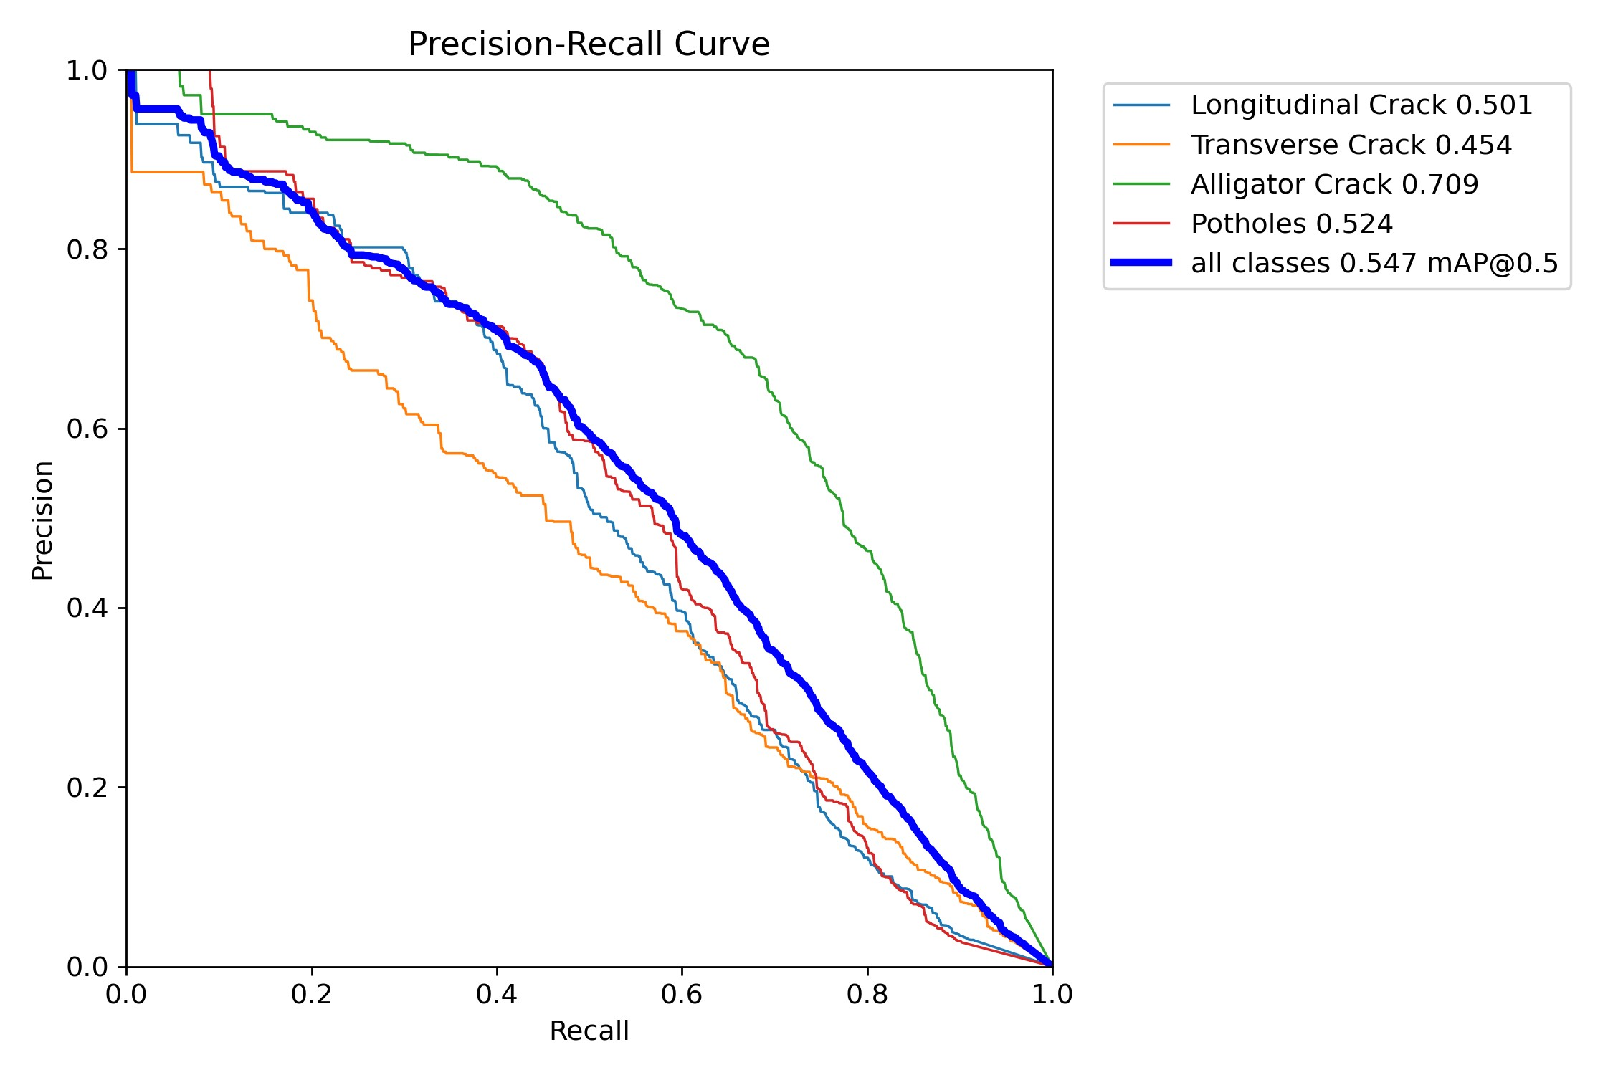
Fig 6.1: Precision-Recall curve on the validation set
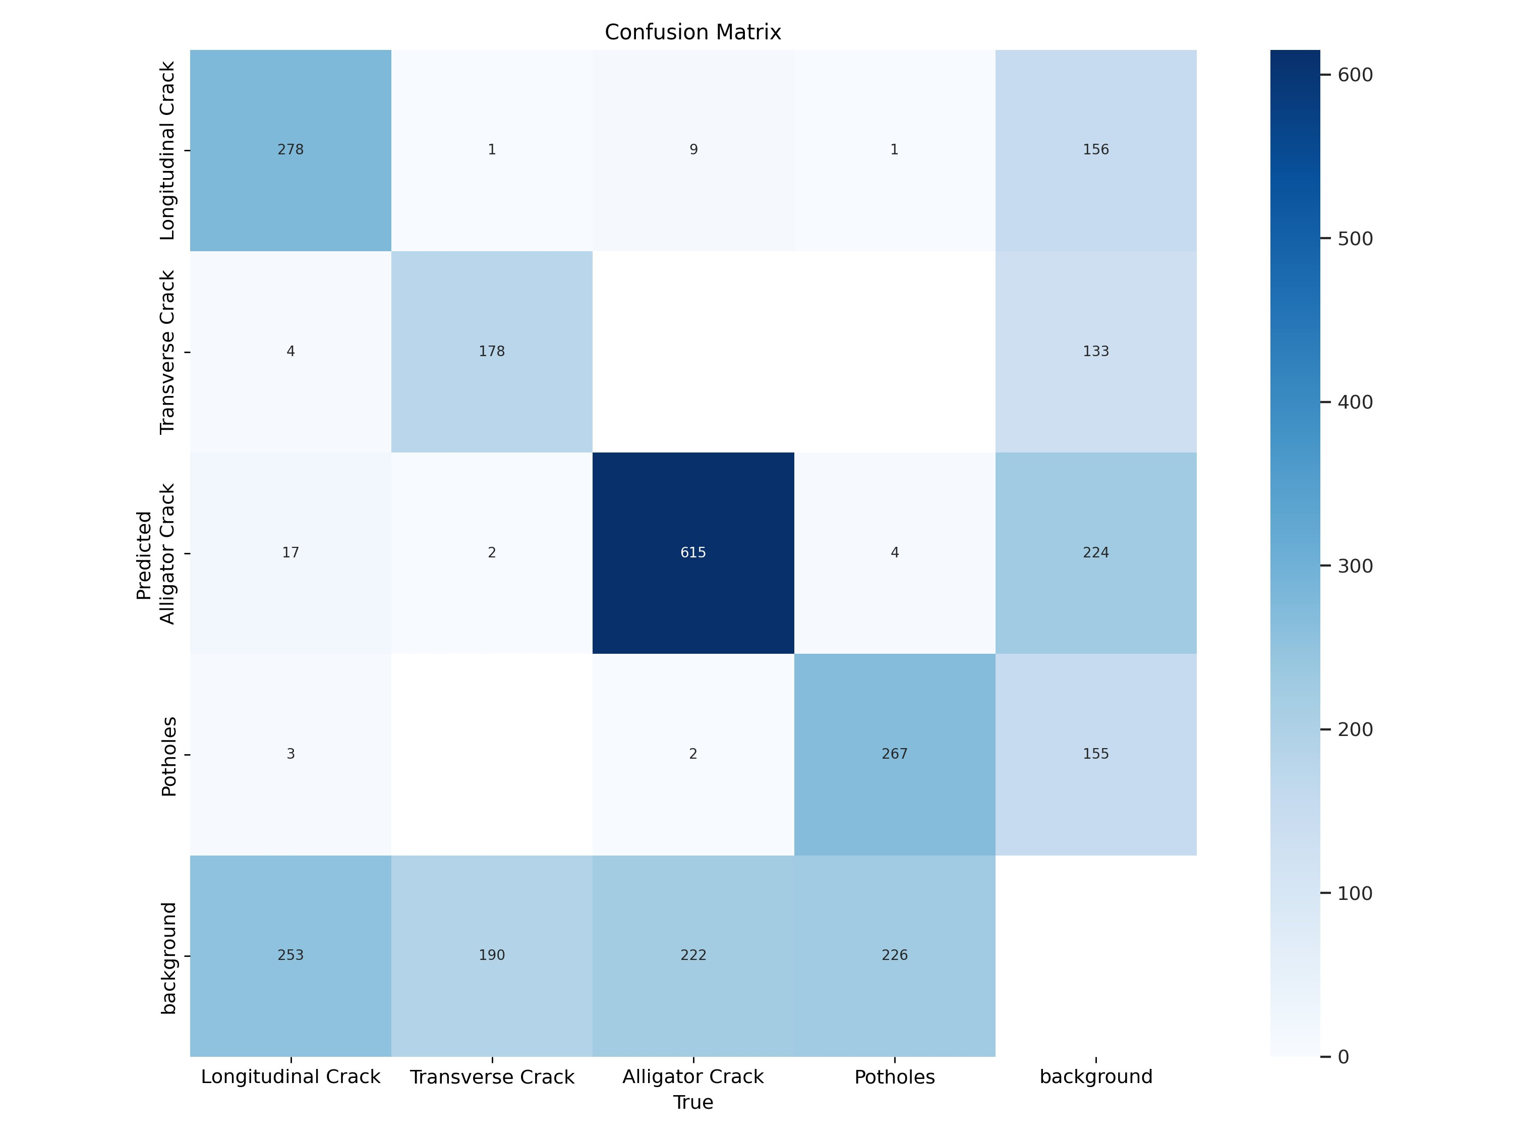
Fig 6.2: Confusion matrix of the trained model
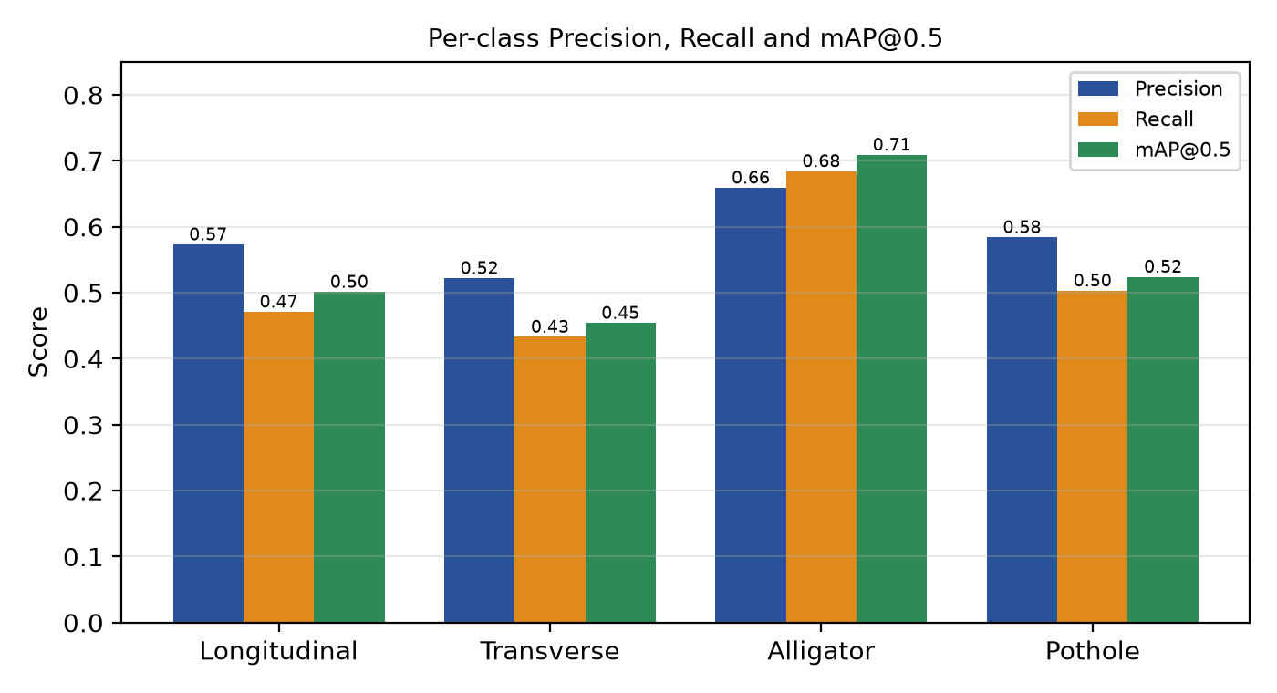
Fig 6.3: Per-class precision, recall and mAP@0.5
Discussion of the results
- Alligator cracks are detected best (mAP@0.5 = 0.709, F1 = 0.671). They are large, textured regions with a distinctive mesh pattern and are the most frequent class in the validation set (848 instances), and 615 of them were correctly detected.
- Transverse cracks are the hardest class (mAP@0.5 = 0.454). They are thin and short, occupy few pixels at 640 × 640 resolution and are easily confused with joints, pavement edges and shadows.
- Few confusions between damage classes. In the confusion matrix, the off-diagonal entries between the four damage classes are very small (for example, only 9 longitudinal cracks were predicted as alligator cracks and 17 alligator cracks as longitudinal). The classifier therefore rarely mixes up damage types; the main errors are missed damage (253, 190, 222 and 226 instances of the four classes were predicted as background) and false alarms on background (133 to 224 per class).
- Precision–recall trade-off. The PR curves show that precision stays above about 0.8 up to a recall of roughly 0.3 and falls steadily beyond it, which is why a user-adjustable confidence threshold is provided in the application.
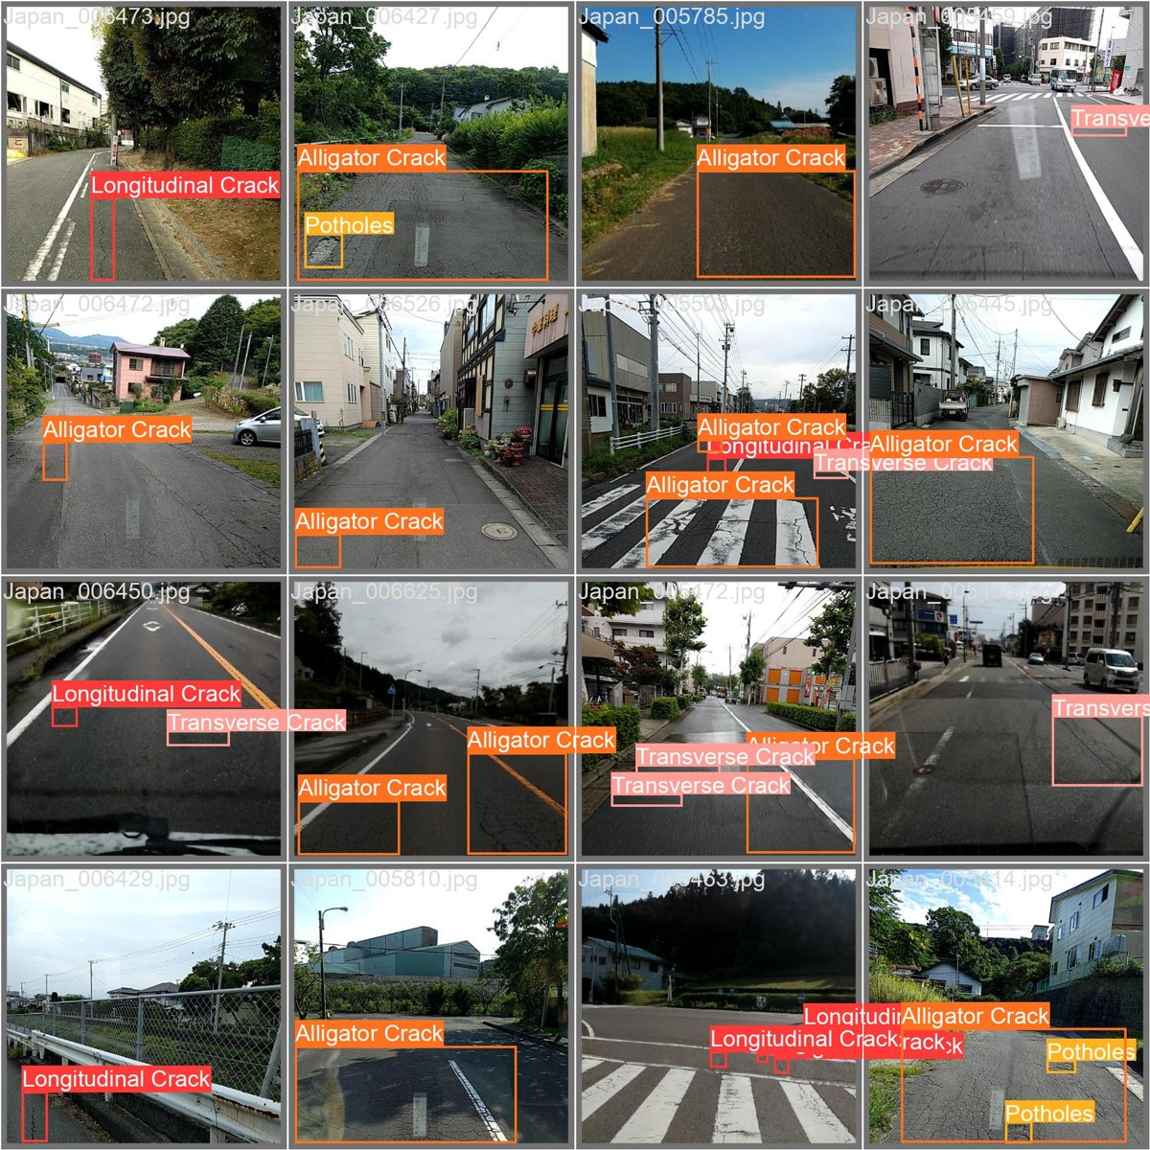
Fig 6.4(a): Ground-truth labels on a validation batch
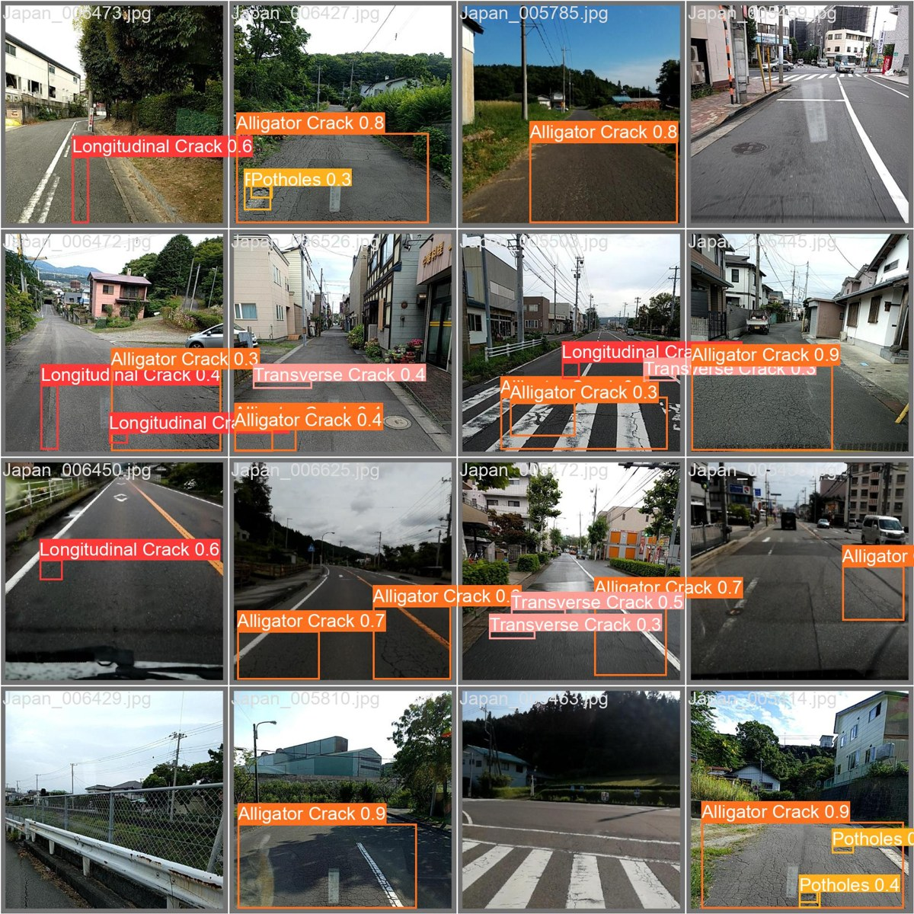
Fig 6.4(b): Model predictions on the same validation batch
Qualitatively, the predictions in Fig 6.4 closely follow the ground-truth boxes for clearly visible damage, while faint and very thin cracks are sometimes missed or detected with low confidence.
Status of the objectives
Table 6.2: Objectives and their status
Objective | Status | Remarks
Detect damage from images/video | Achieved | Image and video detection pages implemented
Classify into four damage classes | Achieved | Four-class YOLOv8s detector
Train and evaluate CNN detector | Achieved | mAP@0.5 = 0.547 on validation set
Robustness to imaging conditions | Partly achieved | Input normalisation and threshold control; no extra denoising or augmentation (mosaic disabled)
Structured output with location and severity | Partly achieved | Class and confidence per detection; GPS tagging and severity scoring left as future work
Evaluate with P, R, F1, mAP | Achieved | Table 6.1 and Figs 6.1–6.4

6.1 Future Scope
- Realtime detection: after further lab evaluation of latency and accuracy, enable live webcam and in-vehicle camera detection on the Realtime page.
- GPS tagging and mapping: attach the GPS coordinates of the camera to every detection so that damaged road sections can be plotted on a map and shared with maintenance authorities.
- Severity estimation: estimate the size and depth of potholes and the extent of cracking to classify severity and prioritise repairs.
- Better accuracy: train a larger YOLOv8 variant or use higher input resolution, add augmentation suited to thin cracks, balance the classes, and incorporate more countries from RDD2022, particularly to improve transverse and longitudinal crack detection.
- Maintenance dashboard: generate reports with counts of each damage type per road segment and trends over time.
- Edge deployment: export the model (ONNX/TensorRT/TFLite) to run on smartphones and embedded devices.

Chapter 7: Conclusion
This project demonstrated that road surface damage can be detected and classified automatically from ordinary images and video using a YOLOv8s model trained on the Indian subset of the RDD2022 dataset. The complete workflow — annotation conversion, class filtering, controlled background retention, reproducible splitting, training, evaluation and deployment — was implemented and documented in three notebooks and a Streamlit application.
On the validation set the model achieved a precision of 0.584, a recall of 0.523, an F1-score of 0.552 and an mAP@0.5 of 0.547 across the four damage classes, with alligator cracks detected best (mAP@0.5 = 0.709) and transverse cracks hardest (0.454). The confusion matrix shows that the model seldom confuses one damage type for another and that most errors are missed or spurious detections, and at about 13 ms per image on a mid-range GPU it is fast enough for video processing.
The web application makes the model usable by non-experts: users can upload an image or a video, adjust the confidence threshold, inspect the annotated output together with a table of detections, and download the results. Realtime detection has intentionally been postponed until it has been evaluated further in the lab, and GPS tagging, severity estimation and accuracy improvements for thin cracks are identified as the most valuable next steps. Overall, the project provides a solid, extensible foundation for low-cost, automated road condition monitoring.

Chapter 8: References
- Arya, D., Maeda, H., Ghosh, S. K., Toshniwal, D., Sekimoto, Y. “RDD2022: A multi-national image dataset for automatic road damage detection.” arXiv:2209.08538, 2022.
- Arya, D. et al. “Crowdsensing-based Road Damage Detection Challenge (CRDDC’2022).” IEEE International Conference on Big Data, 2022. Dataset: github.com/sekilab/RoadDamageDetector.
- Jocher, G., Chaurasia, A., Qiu, J. “Ultralytics YOLOv8.” 2023. github.com/ultralytics/ultralytics and docs.ultralytics.com.
- Redmon, J., Divvala, S., Girshick, R., Farhadi, A. “You Only Look Once: Unified, Real-Time Object Detection.” IEEE CVPR, 2016.
- Lin, T.-Y. et al. “Microsoft COCO: Common Objects in Context.” ECCV, 2014.
- Paszke, A. et al. “PyTorch: An Imperative Style, High-Performance Deep Learning Library.” NeurIPS, 2019.
- Bradski, G. “The OpenCV Library.” Dr. Dobb’s Journal of Software Tools, 2000. opencv.org.
- Streamlit Inc. “Streamlit documentation.” docs.streamlit.io.
- oracl4. “RoadDamageDetection” – open-source YOLOv8 road damage detection application and training notebooks, 2023. github.com/oracl4/RoadDamageDetection (used as the starting point for the training protocol, baseline weights and web-application structure, which were studied, re-run, evaluated and extended in this project).

